**Waverly Yowell Elementary School**

**4th Grade Supply List**

**2025-2026**

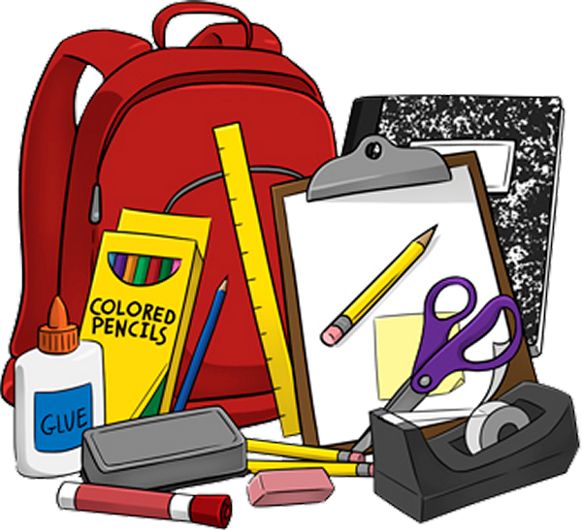

**Supplies Needed:**

* 4 **wide ruled** spiral notebooks
* 1 pencil box (**NO** lock boxes) or 1 pencil pouch
* 2-3 **plastic** folders- any colors
* 1 pair 5” scissors
* 1 box of crayons or colored pencils
* 60+ #2 pencils
* 2 yellow highlighters
* 2-4 black dry erase markers
* 6+ **LARGE** size glue sticks

**Optional (Needed in our classroom but not required):**

* Large boxes of tissues
* Ziploc gallon storage bags and/or sandwich bags
* Antibacterial hand sanitizer (pump bottle)
* Clorox/Disinfecting Wipes
* Paper Towels